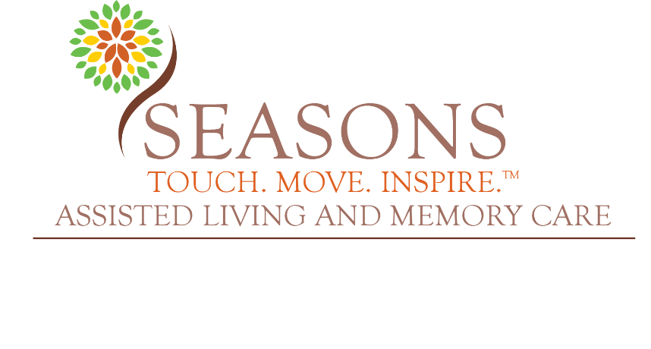

Seasons Largo Assisted Living & Memory Care Community Visitation Policy and Procedures

Purpose: This document provides the Community, Residents, and Staff with guidance for all in-person visitation, in accordance with Section 408.823, Florida Statutes; also known as the “No Patient Left Alone Act.”

Availability of Policy:
- The “Seasons Largo Assisted Living & Memory Care Visitation Policy & Procedures” is available on the community’s website at: www.seasonsalf.com.
Designation of Responsible Person:
- The Community will designate the Administrator as the person responsible for ensuring staff adherence to the Visitation Policy and Procedures for Seasons Largo Assisted Living & Memory Care.
General Visitation Policies:
- Visitors are welcome to visit at any time. General visiting hours are from 9:00 am – 8:00 pm.
- After 8:00 pm, visitors should call the community’s main phone number at the front door, (727) 330-7898, and staff will provide them with access.
- There is no limitation on the visitation length.
- The community has no limit on the number of visitors per resident. The community may limit the total number of visitors allowed in the facility at any given time based on the ability of staff to safely monitor the space used to accommodate the visitors.
Infection Control Policies & Procedures:
- Visitors are not required to provide proof of any vaccination or immunization.
- This policy allows consensual physical contact between a resident and a visitor.
- The Community will screen the Visitor per the Community’s infection control policy and procedures.
- The Community will document the name of the individual, the date, and time of entry.

- Visitors will be provided with education on the Community’s infection control policy and procedures. Safety-related policies and procedures are not more stringent than those established for staff of the community.
- Visitors who currently meet the criteria for quarantine, based on the current CDC guidelines, should not enter the Community.
- This policy does not prohibit visits if the Resident to be visited is quarantined, tested positive, or showing symptoms of a communicable disease. Visits in these circumstances will require a higher level of Personal Protective Equipment (“PPE”) than standard masks. PPE will be provided to the Visitor and will be in accordance with the most recent CDC guidance for healthcare workers.
- The community recognizes that a resident or a resident’s responsible party may designate a visitor who is a family member, friend, guardian, or other individual as an “essential caregiver.” The community will allow in-person visitation by the “essential caregiver” for at least 2 hours daily in addition to any other authorized visitation. The community does not require “essential caregivers” to provide necessary care to a resident. The designated “essential caregiver” will be documented in the resident’s electronic medical record and updated upon the resident’s responsible party’s request.
- Residents are allowed in-person visitation in all the following circumstances, unless the resident objects: a. End-of-life situations; b. Resident who was living with family before being admitted to the provider’s care is struggling with the change in environment and lack of in-person family support; c. Resident’s responsible party is making one or more major medical decisions; d. Resident is experiencing emotional distress or grieving the loss of a friend or family member who recently died; e. Resident needs cueing or encouragement to eat or drink which was previously provided by a family member or caregiver; f. Resident who used to talk and interact with others is seldom speaking.
All visitors to our communities are responsible for:
- Being respectful and considerate of the rights and needs of other residents, staff members and visitors.
- Being sensitive to noise level, number of visitors and the communities’ smoke-free environment.
- Following this policy and other communities’ policies and procedures that the visitor is made aware of.
The community does not require visitors to agree in writing to follow the visitation policies and community procedures. However, if the visitor has violated the policies and procedures, the community may suspend in-person visitation for the specific individual.

